**Exercise 1: Control Structures**

**Scenario 1:**

The bank wants to apply a discount to loan interest rates for customers above 60 years old.

* + **Question:** Write a PL/SQL block that loops through all customers, checks their age, and if they are above 60, apply a 1% discount to their current loan interest rates.

**Queries:**

CREATE TABLE Customers (

CustomerID NUMBER PRIMARY KEY,

CustomerName VARCHAR2(100),

Age NUMBER,

Balance NUMBER,

IsVIP VARCHAR2(5)

);

CREATE TABLE Loans (

LoanID NUMBER PRIMARY KEY,

CustomerID NUMBER REFERENCES Customers(CustomerID),

InterestRate NUMBER(5,2),

DueDate DATE

);

INSERT INTO Customers VALUES (1, 'John Doe', 65, 12000, 'FALSE');

INSERT INTO Customers VALUES (2, 'Jane Smith', 45, 8000, 'FALSE');

INSERT INTO Customers VALUES (3, 'Robert Brown', 70, 15000, 'FALSE');

INSERT INTO Loans VALUES (101, 1, 7.5, TO_DATE('2025-07-15', 'YYYY-MM-DD'));

INSERT INTO Loans VALUES (102, 2, 8.0, TO_DATE('2025-07-10', 'YYYY-MM-DD'));

INSERT INTO Loans VALUES (103, 3, 6.5, TO_DATE('2025-07-20', 'YYYY-MM-DD'));

COMMIT;

**PL/SQL:**

SET SERVEROUTPUT ON;

DECLARE

CURSOR customer_cursor IS

SELECT CustomerID, Age FROM Customers;

BEGIN

FOR cust_rec IN customer_cursor LOOP

IF cust_rec.Age > 60 THEN

UPDATE Loans

SET InterestRate = InterestRate - (InterestRate * 0.01)

WHERE CustomerID = cust_rec.CustomerID;

DBMS_OUTPUT.PUT_LINE('Applied 1% discount for Customer ID: ' || cust_rec.CustomerID);

END IF;

END LOOP;

COMMIT;

END;

/

**Output:**

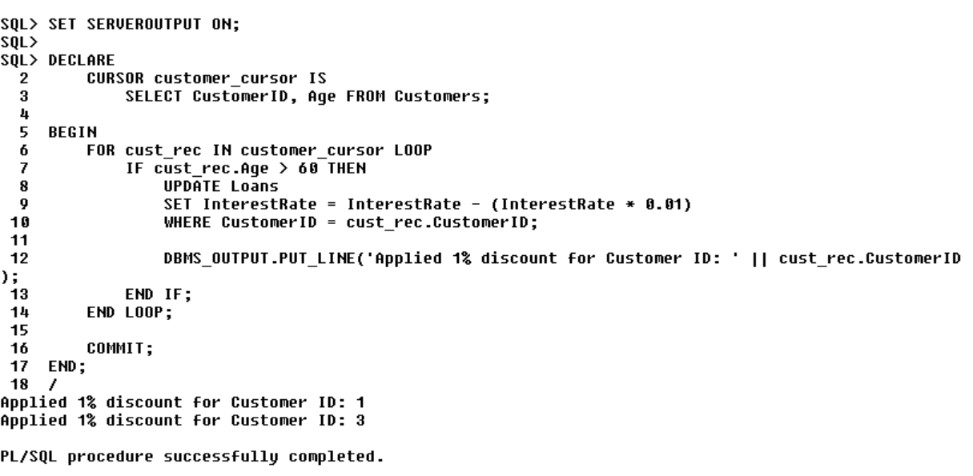

**Scenario 2:**

A customer can be promoted to VIP status based on their balance.

* + **Question:** Write a PL/SQL block that iterates through all customers and sets a flag IsVIP to TRUE for those with a balance over $10,000.

**PL/SQL:**

SET SERVEROUTPUT ON;

BEGIN

FOR cust_rec IN (SELECT CustomerID, Balance FROM Customers) LOOP

IF cust_rec.Balance > 10000 THEN

UPDATE Customers

SET IsVIP = 'TRUE'

WHERE CustomerID = cust_rec.CustomerID;

DBMS_OUTPUT.PUT_LINE('Customer ID ' || cust_rec.CustomerID || ' promoted to VIP.');

END IF;

END LOOP;

COMMIT;

END;

/

**Output:**

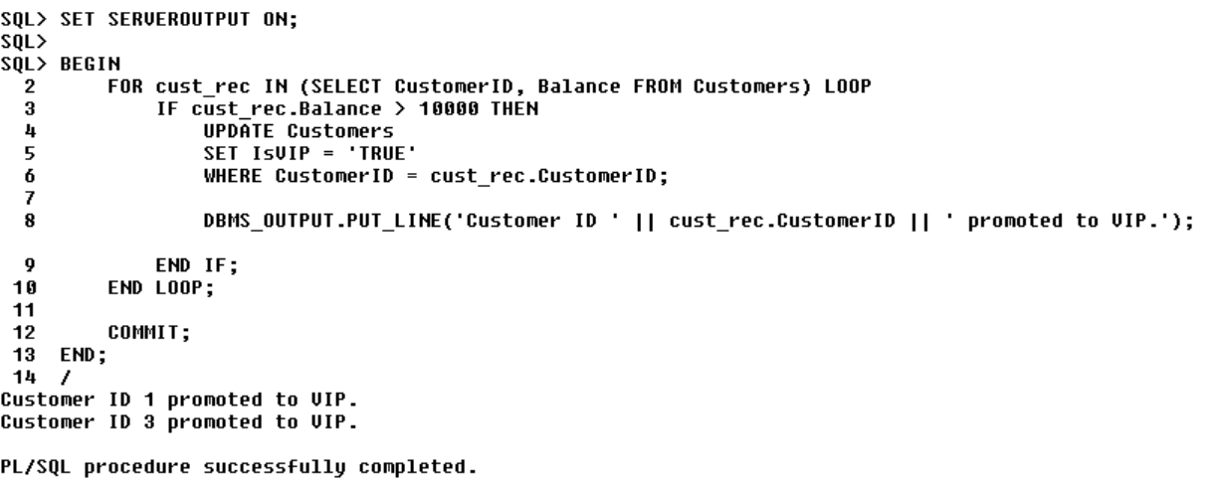

**Scenario 3:**

The bank wants to send reminders to customers whose loans are due within the next 30 days.

* + **Question:** Write a PL/SQL block that fetches all loans due in the next 30 days and prints a reminder message for each customer.

**PL/SQL:**

DECLARE

CURSOR loan_cursor IS

SELECT LoanID, CustomerID, DueDate

FROM Loans

WHERE DueDate BETWEEN SYSDATE AND SYSDATE + 30;

BEGIN

FOR loan_rec IN loan_cursor LOOP

DBMS_OUTPUT.PUT_LINE('Reminder: Loan ID ' || loan_rec.LoanID ||

' for Customer ID ' || loan_rec.CustomerID ||

' is due on ' || TO_CHAR(loan_rec.DueDate, 'DD-MON-YYYY'));

END LOOP;

END;

/

**Output:**

